**MAIN MENU AND IT’S SUB MENU(s)**

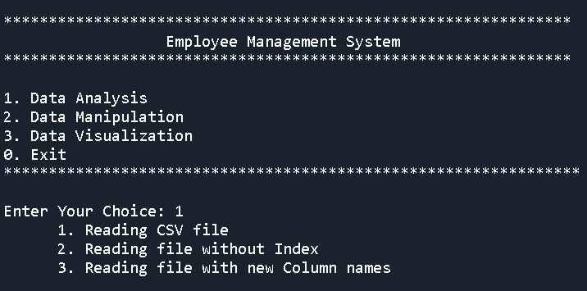

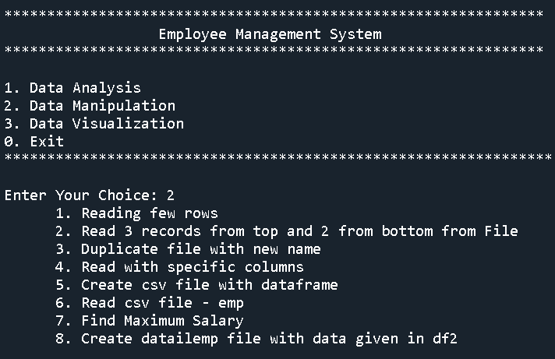

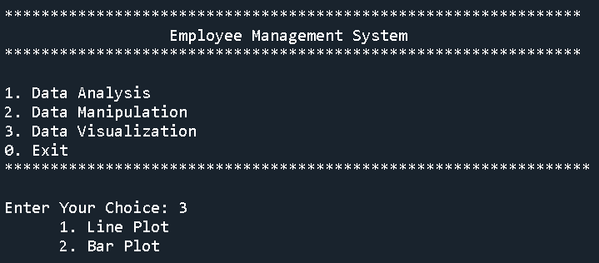

**MENU OPTION 1 AND IT’S SUB-MENU 1**

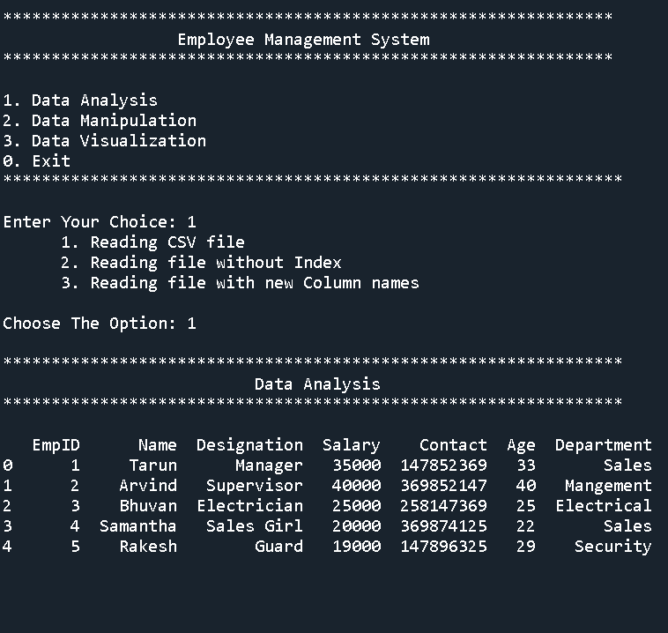

**MENU OPTION 1 AND IT’S SUB-MENU 2**

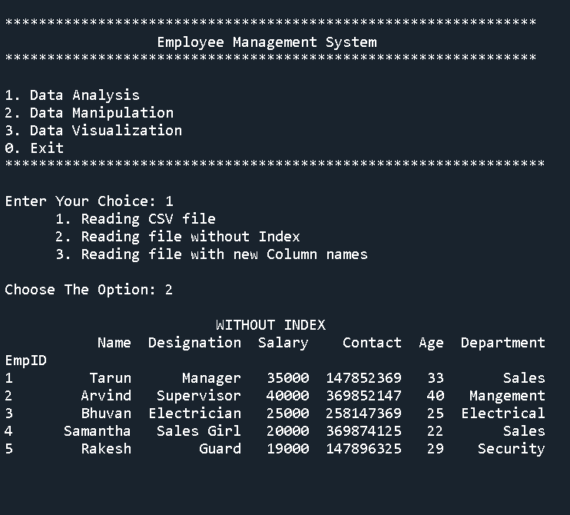

**MENU OPTION 1 AND IT’S SUB-MENU 3**

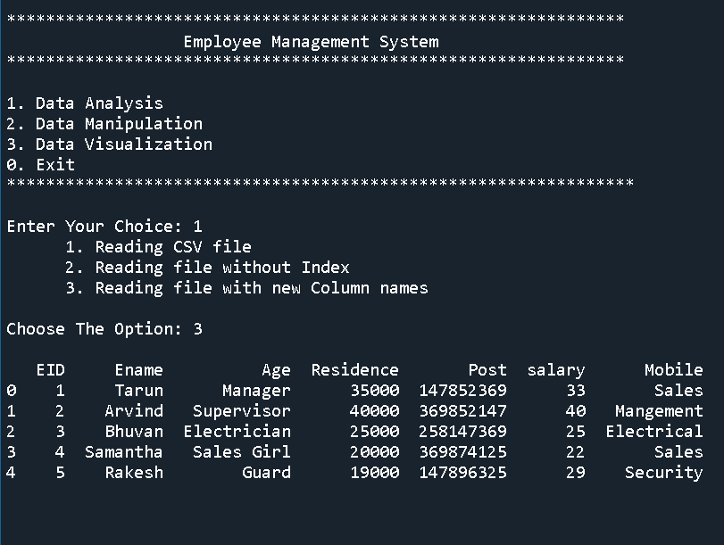

**MENU 2 AND IT’S SUB-MENU 1**

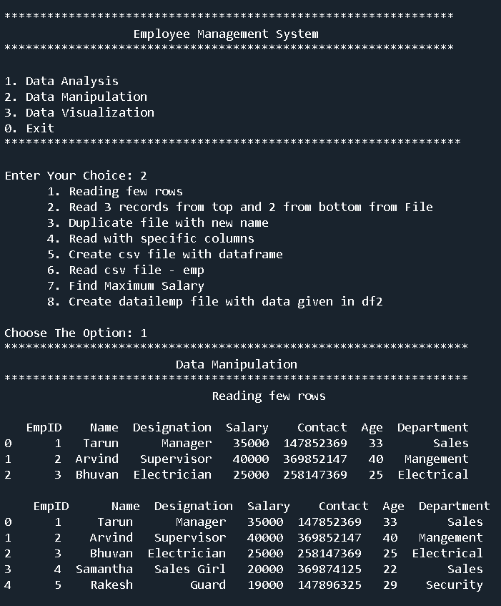

**MENU OPTION 2 AND IT’S SUB-MENU 2**

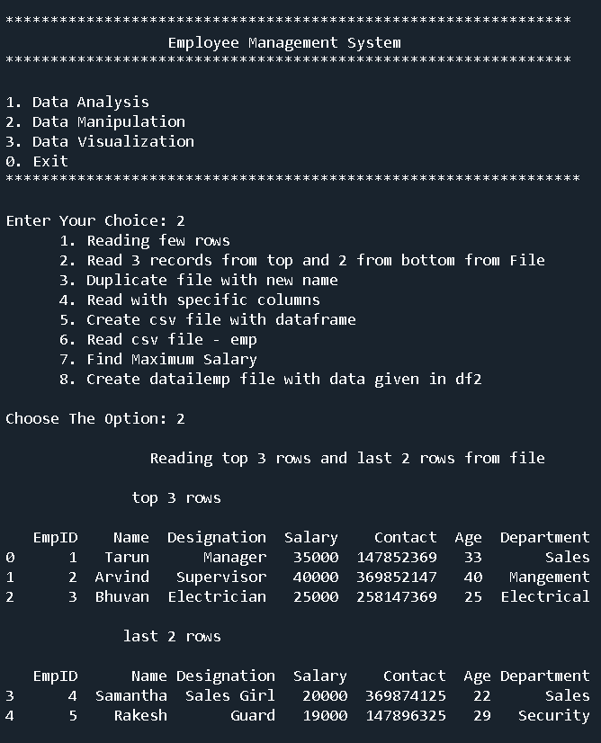

**MENU OPTION 2 AND IT’S SUB-MENU 3**

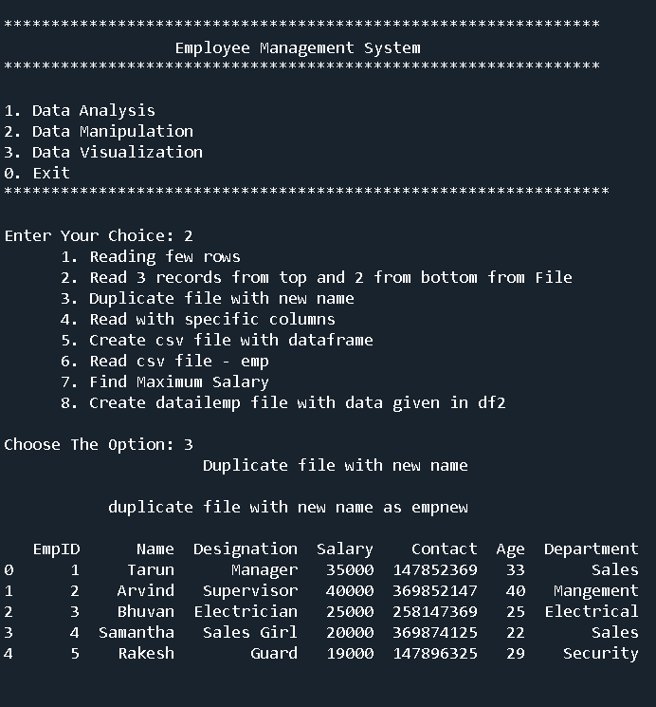

**MENU OPTION 2 AND IT’S SUB-MENU 4**

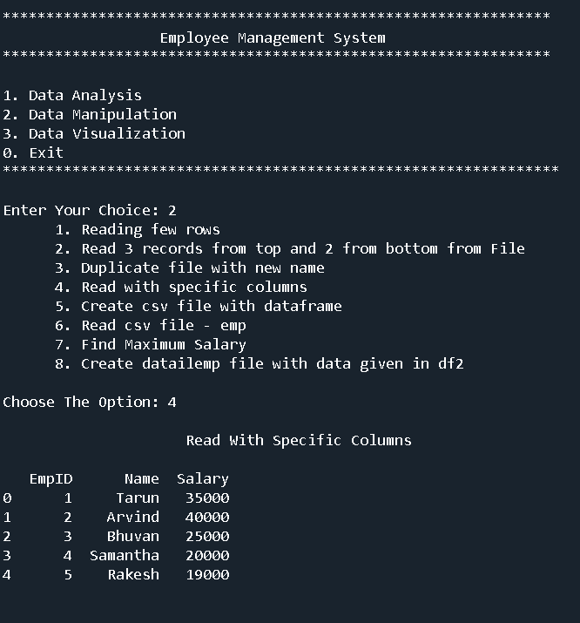

**MENU OPTION 2 AND IT’S SUB-MENU 5**

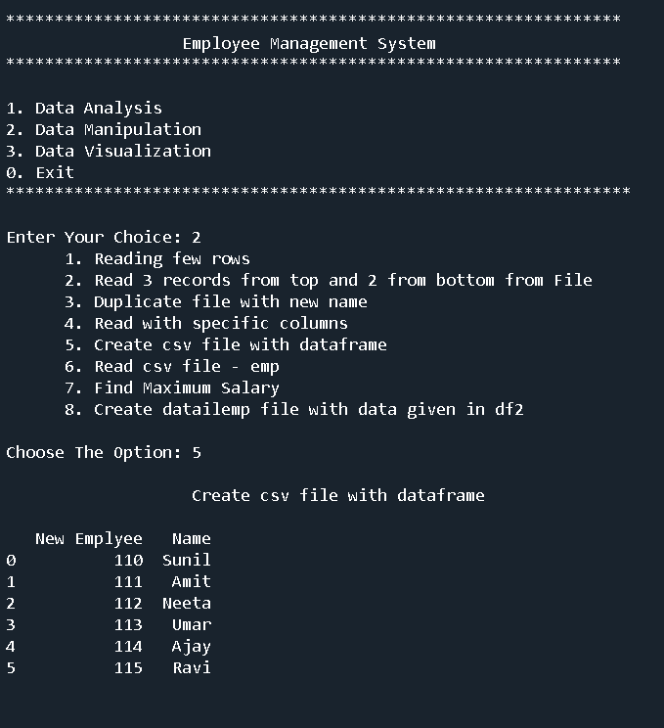

**MENU OPTION 2 AND IT’S SUB-MENU 6**

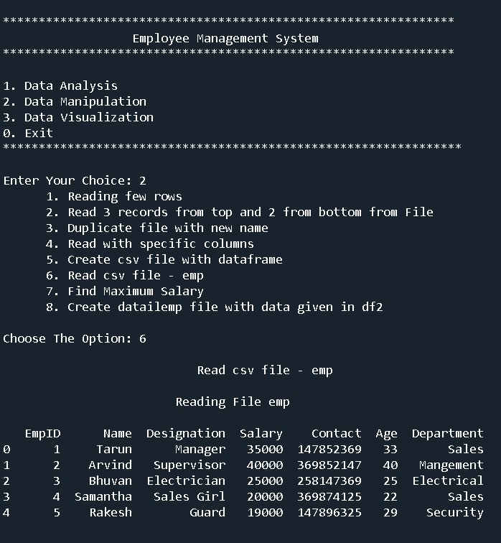

**MENU OPTION 2 AND IT’S SUB-MENU 7**

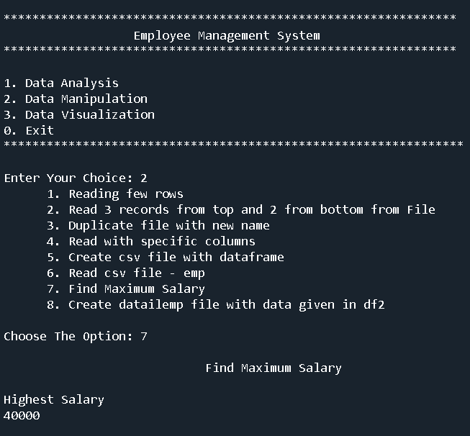

**MENU OPTION 2 AND IT’S SUB-MENU 8**

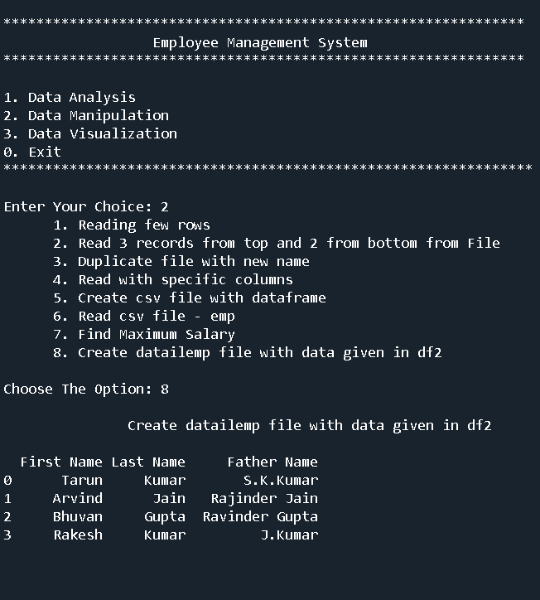

**MENU OPTION 3 AND IT’S SUB-MENU 1**

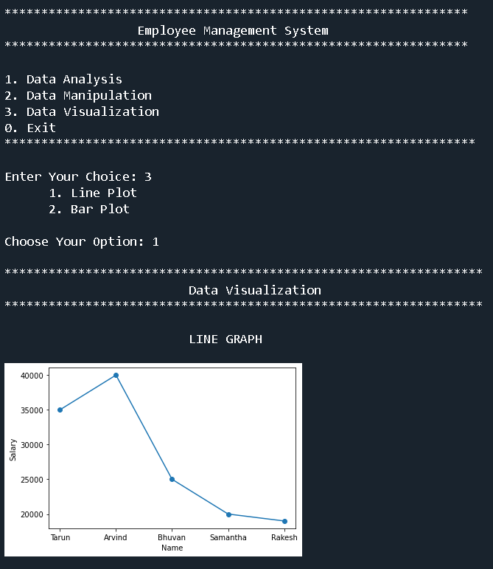

**MENU OPTION 3 AND IT’S SUB-MENU 2**

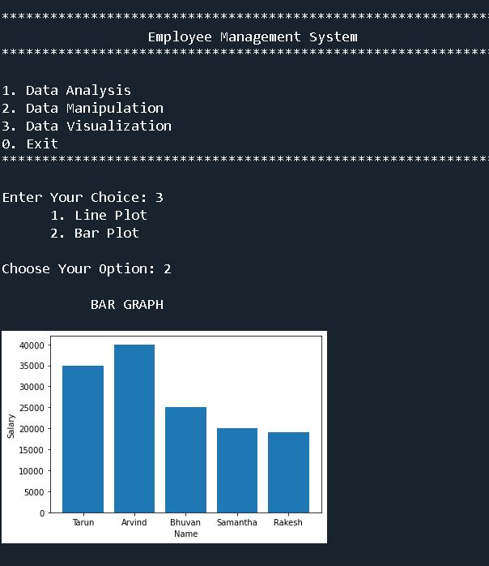

**MAIN CSV FILE**

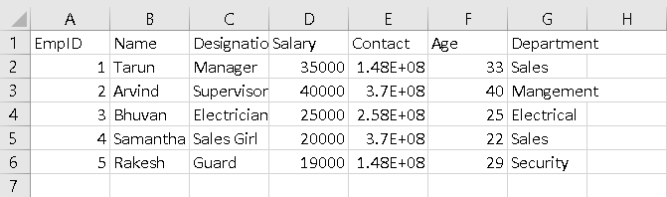

**CREATED CSV FILE USING DATAFRAME**

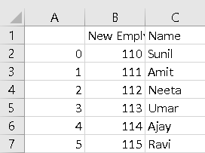

**DETAILED EMPLOYEE FILE CREATED USING DATAFRAME**

